
ACTS OF WAR!

JESUS/ALEXANDER

&
JFK

WITH CLEAR, CREDIBLE, AND CONVINCING

NEW EVIDENCE!


A Series of Six Reports

GARY REGINALD DODGE

7th Revised Edition

© Copyright 2004, 2019 Gary Reginald Dodge. All rights reserved.

No part of this book may be reproduced, stored in a retrieval system, or transmitted by any means, electronic, mechanical, photocopying, recording, or otherwise without written permission from the author.



Composed in the United States of America

San Francisco, California

TABLE OF CONTENTS

ALEXANDER THE CHRIST

THE LEGACY OF ALEXANDER LIVES ON THROUGH SUN TZU’S THE ART OF WAR

ADDENDUM TO ALEXANDER THE CHRIST, and, THE LEGACY OF ALEXANDER LIVES ON…

ROGUE ELEMENTS I & II

‘President’s throat Rostow --- Did the operation’

PRESIDENT LYNDON B. JOHNSON’S POSTHUMOUS INDICTMENTS OF THE LATE-PROFESSOR DOCTOR WALT

WHITMAN ROSTOW

CASE CLOSED

NOTHING NEW UNDER THE SUN

Dear Treasured Reader,

These first three reports are about the remarkable deeds of a young King who is the root of modern Western Civilization. Alexander III is the Father of Democracy, and his mentor was Aristotle, the Father of Philosophy. He brought to destitute and suffering people the three-hundred-years old medicines of Hippocrates. He brought the policies of democratika to nations previously ruled by despots and tyrants of all types. During his brief reign he brought civilized discourse, or swift defeat, to oligarchies in seventeen countries and thirty-one cities, and there are eight cities across Asia named Alexandria to the present day. This record, (and modern Western Civilization), stands today because of his extraordinary military and political victories over two-thousand years ago.

ALEXANDER THE CHRIST is my learned opinion, and I stand by it.

THE LEGACY OF ALEXANDER, and, ADDENDUM TO.., both break new ground, as well.

ROGUE ELEMENTS, and the accompanying commentary, CASE CLOSED, drives into uncharted territory involving the fifty-years-long ‘planning’ to destroy democracy in these United States by silencing popular Democrats, and their supporters, through all manner of bloody murder, mayhem, and dirty tricks.

NOTHING NEW UNDER THE SUN is the heretofore untold History of AIDS, from its beginning,

and to its very end.



ALEXANDER THE CHRIST

Alexander III of Macedonia became king when his father, King Philip the Great, was assassinated on the eve of departure to meet and defeat the Persian Army, which was encroaching on Greek territory. Foremost he destroyed Tyre, the Jewel in the Crown of the evil-Persian Empire, and home to pirated goods. Tyre dominated the Mediterranean for four hundred years, and nobody believed it would ever fall. Situated one-quarter mile off the coast of modern-day Syria, its 150ft-high walls enclosed a small city within its seventeen-mile, haphazard circumference. He accomplished this difficult task by instructing his engineers to construct a mole, (a sea-level roadway), enabling his newly designed catapults to be within range. The battle raged for seven months, and at a great cost to his army. The enemy soldiers poured boiling oil and red-hot sand on the attackers, and threw captured soldiers off the top of the walls to the rocks below.

When the southern wall was finally breached, it appeared Alexander walked on water, for so it is written “ …or so it would appear at a distance.” Alexander washed his hands, and left it up to his army to punish the enemy, which they did, by crucifying 8,000 enemy combatants, (where they were left for the desert night beasts of all sizes to come out and feast on them, while still alive), and sold the remaining 20,000 into slavery, including the wife, mother, and child of Darius III, King of Persia, who begged for their return, but Alexander bowed to the will of his army.

Furthermore, in the Gospel According to Matthew, Ch. 11, v. 21, and again in the Gospel of Luke, 10:13, reads, ‘Woe unto you Chorazin for the same will happen to you as what happened to Tyre and Sidon.’ Alexander, not the mythical Jesus, destroyed both Tyre and Sidon.

The parallels between Alexander the Great, and the myth of ‘Jesus’ do not end there. Both are believed to have met their Earthly demise at the age of 33. Both were worshiped by many followers who believed they were in the presence of a living “god.” Both were (falsely) accused of blasphemy, yet only one earned the nom de guerre, KING OF KINGS AND LORD OF LORDS, (from the Book of the Revelations, Ch. 19, v. 16), and that would be Alexander when he destroyed the capital of the Ancient Persian Empire, Babylon, which was spoken by Alexander, and recorded by his six scribes, (for accuracy), in real-time, post-campaign, as such, “Woe, woe O Great City! O Babylon city of power. In one hour your doom has come,” (Book of the Revelations, Ch. 18, v. 10). Alexander out-flanked the million-man Persian Army, and struck Babylon from the north. Forty-miles NNE of Baghdad, Iraq, there is a small pile of rock and dirt; all that is left of Ancient Babylon, (and even less so in memory).

So, do you still believe in an immaculately conceived Jewish Messiah who, contrary to simple logic, performed miracles, and walked on water, and was crucified for our sins, and had risen up from the grave to prepare a place for us in Heaven, if only we believe in Him? (I believe the grave is rather permanent.)

Or do you think that a great king could be falsely accused, and overthrown in a staged riot? In The Acts of the Apostles, Chapters 19, and 20, verses 33, titled, The Riot at Ephesus, (the Temple at Ephesus was Alexander’s birthplace): ‘The Jews pushed Alexander forward and Alexander held out his hand as if to give his own defense,’ and, “I have coveted no man’s gold, or silver, or apparel,” (this being his defense against malicious accusations of seeking to profit from his many conquests), and was nailed to the tree, yet miracle of miracles, did not die?*

The former requires a tremendous leap of faith, while the latter requires only a minimal amount of critical thinking. Alexander’s many conquests, (17 nations, and 31 cities), defines his true heroism. No commander, king, emperor, or general even comes close to that amazing record, before or since.

Does it not make sense, then, that a king, so young, so brave, and so intelligent, and who crushed so many sinister and diabolical regimes could be considered a ‘god’ in the eyes of a primitive and otherwise oppressed people, and wonder of wonders, cheated death in what could only be described as ‘a miracle?’

Concluding, therefore, that Alexander III of Macedonia, (called ‘the Great’), was the one true, living Christ, the obvious question remains: ‘Who, then, was the anti-Christ?’ Ch. 13, v. 18 of the Revelations, reads: “Let him who has wisdom know, (a formal education which would include Chemistry), that, “He has the number of a man; Six, three score, and six.” In the Periodic Table of Elements, “Six,” (6), is the Atomic Number for Carbon, (the basic ingredient of all life). The Table of Elements having already been referenced, “three-score and six,” (66), is the Atomic Number for ‘dysprosium ,’ (from the Greek , dysprositos , meaning , “hard to get at,” with the Symbol, ‘Dy').

Throughout the entire Bible there is only one name that begins with ‘Dy,’ (or Di). In the 3rd John, “Diotrephes,” who was, in point of fact, ‘hard to get at;’ “I wrote to the church, but Diotrephes, who loveth to have the preeminence among men, will have nothing to do with us… gossiping maliciously about us… and not content with that, he will not receive the brothers.” Alone among all names in the Bible that is associated with, “that which is evil,” Diotrephes would most necessarily be Diogenes, a well-known detractor of Alexander, and the founder of the Cynical school of philosophy, which believed, “No Earthly good can result from any human endeavor, no matter how well intended,” (a creed, not a philosophy), and unlike Diogenes, there is no historical record, (outside of the Scriptures), of a Diotrephes. Yes, dear, treasured reader, Diogenes was the anti-Christ, so relax, because he is long gone, now…

*Acts of the Apostles, Ch. 5 v. 30, ‘The God of our fathers raised Jesus from the dead --- whom you murdered by hanging him on a tree.’ Ch. 10 v. 39, ‘And we are witnesses to everything he did, both in the land of the Jews and in Jerusalem, when they killed him by hanging him on a tree, but God raised him from the dead, and caused him to be seen.’

THE LEGACY OF ALEXANDER LIVES ON THROUGH SUN TZU’S

THE ART OF WAR


In the New Testament of the Holy Bible, in the book titled, The Second Epistle of Paul, the Apostle, to Timothy, Paul charges Timothy, (‘ …whom Jesus loved.’), ‘Bring the cloak that I left with Carpus at Troas when you come- and the books, especially the parchments.’

‘Paul’ never did get the books, or the parchments, because, “the books, especially the parchments, were actually the now famous, and highly sought after antiquity, The Lost Papers of Alexander, which are in reality, ‘Sun Tzu’s’ The Art of War, a more than two-Millennium-old, (Chinese), treatise on war, popular among Western business persons throughout the 1980s and ‘90s as a generic tome applicable to doing business in a hostile, and competitive environment. It remains unsurpassed in its originality and in its elegant prose.

In the chapters titled, ‘The Nine Varieties of Ground,’ verse 51 reads: “One ignorant of the plans of neighboring states cannot prepare alliances in good time; if ignorant of the conditions of mountains, forests, dangerous defiles, swamps and marshland, he cannot conduct the march of an army. If he fails to make use of native guides, he cannot gain the advantages of the ground. A general ignorant of even one of these three matters is unfit to command the armies of the Hegemonic King,” and verse 52 reads, “Now when a Hegemonic King attacks a powerful State he makes it impossible for the enemy to concentrate. He overawes his enemy and prevents his allies from joining him.”

In the Introduction by Samuel B. Griffith, (who also translated The Art of War into English), after giving much attention to possible, ‘authorship,’ closes the chapter by stating: 'Thus we arrive at the same impasse as did Yao Ch’ing three centuries ago. We do not know if this Sun Wu existed. We do not know if the work ascribed to him was written by him, and we are therefore forced, with the eminent Ch’ing scholar, to place The Art of War in the category, Authorship Unsettled, but its originality, the consistent style, and thematic development suggest the “Thirteen Chapters,” is not a compilation, but was written by a singularly imaginative individual who had considerable practical experience in war.'

This writer would like to add that the work is decidedly not the work of any itinerant policy adviser, but is the life’s-work of an eminently schooled, ‘Aristocrat,’ and there being only one ‘Hegemonic King’ in all of Asia during the time when this work was alleged to have been created, then this writer irrefutably settles on Alexander the Great as the author of, The Art of War, (although Griffith may have given a hint that he knew so, as well).

According to the APPENDIX TO THE VULGATE, Jerome, 4th century, The mythical and mysterious creature known as Jesus was a completely fictional creation by Rabbi Alexander Bar Jesus, who was commissioned by Constantine, (Roman Emperor, 306 - 337), to translate The Bible from the original Greek into Hebrew. Bar Jesus was ordered to erase any semblance of Alexander, because his legacy was so strong and embedded in the conscience of the populace, Constantine could not effectively govern. The good rabbi left a dozen clues to the truth, and was burned at the stake for ‘heresy,’ because it is impossible Constantine did not know what Bar Jesus did, plus he silenced any witnesses to the evil deed.

Constantine conquered, with no provocation, the peaceful, artistic, and educated the 3,000 years old Byzantine Empire, and closed off and sacked its capital, Byzantium, (presently Istanbul, Turkey), and crafted a new calendar that created a spurious and false three hundred years of history, and decreed ‘Constantinople,’ a ‘Christian city,’ and, is the origins of Eastern angst for all things Western. One hundred years later, the Dark Ages fell over Europe, characterized by wide-spread ignorance, intellectual stagnation, and rampant poverty, and Alexander became a long-distant memory.

The birth of the child who would be king was considered a miracle, because his father was thought to be too old and battle-scarred to produce an heir to the throne, yet when the people of Ephesus learned of the successful birth, by Olympia, spasms of joy broke out, and the Temple at Ephesus was accidentally burned to the ground. The wealthy ladies of Ephesus donated their jewelry and conducted a fund-raising campaign that produced enough funds to rebuild the Temple in three days, (and which today is one of the Seven Wonders of the World). When Jesus was suffering on the cross, ignorant passersby blaspemed him, saying, “You who destroyed the temple and rebuilded it in three days, come down from the cross!”

The light from the seventeen-acre burning temple alarmed much of Asia Minor, and Kings from the East, upon learning of the birth of Alexander, went to see the child, and brought gifts for the new-born King, who was placed in a manger, (a feed bin for livestock), because with the temple destroyed there was no other place for him. (He was educated in the three-thousand-years-old Egyptian Empire, which he would later conquer peacefully, and without violence, and was crowned, ‘Pharaoh;’ the Egyptian embodiment of God.

ADDENDUM TO:

ALEXANDER THE CHRIST, AND THE LEGACY OF ALEXANDER LIVES ON THROUGH

SUN TZU’S THE ART OF WAR

Now there has been renewed interest in the exploits of this great, young Macedonian King. Historians and amateur History buffs are convinced that he died at the age of thirty-two of either malaria, or from wounds suffered in the Battle for Babylon, but in fact, he lived much longer. He did not look to be his age of thirty-three. He was a deceptively strong individual. He force marched on foot for seven years and 17,000 miles at the lead of his ever growing army, (with every conquest), throughout Asia, Egypt, and up to India.

He was educated in Egypt, which he would conquer without violence, and was named Pharaoh, the Egyptian equivalent to God. He installed his sister, Cleopatra, as Queen of Egypt, who ruled, history says, from 48 - 30 BC. She was paramour to Marc Antony, and Julius Caesar, and so, here we see where Constantine’s calendar is flawed. Alexander is said to have lived 356 BC-323 BC. That would make Cleopatra about three-hundred years old, or so...

When his father was assassinated on the eve of departure to meet and defeat the Persian Army, which was encroaching on Greek Territory. Alexander became King of Macedonia, but not before he had to suppress a revolt in the Eastern Provinces, who rebelled against his youth, (at eighteen years). He sought to finish the work of his father by destroying the evil-Persian Empire, whose armies out-numbered his by 10:1.

To an ignorant and oppressed people Alexander was more than just a savior. He was God, in the flesh. Superlatives are not necessary to describe his victories. One has only to look at his record: Porus was a giant of a man who stood over seven feet tall, and who rode a war elephant into battle, as did much of his army; an image daunting enough for his enemies, and their horses, to draw back in terror. Alexander deployed a company of slingers to knock the giant from his mount, and the raging elephants crushed the enemy soldiers.
Alexander, standing over the defeated Porus, asked him how he wished to be
treated... “As a King!” said the giant. This impressed Alexander, and he
restored him to his throne as King of India, and which further earned Alexander the nom de guerre, KING OF KINGS AND LORD OF LORDS. One would think that, considering his immense military and political stature, there would be books written about him, and that is what the Bible is: By-and-large, the living, breathing testament to the awesome power of one, great, King, as spoken to his six scribes, pre- and post-campaign. The exceptions are, but not exclusive to, the letters from John, (Aristotle), and Paul, (Isocrates), who was Judas Iscariot, and who betrayed Alexander with a kiss, thereby identifying him from among his men, for the Romans, the Jews, and the silversmiths, where they all had long hair, mustaches, and beards, and the same smocks, after seven years in the field. (Alexander was known to mingle with his army, pre- and post-campaign.) The Jew Isocrates, (Judas Iscariot), betrayed Alexander with a kiss, for six pieces of silver from the silversmiths, who were enraged when Alexander said, “Make no idols in my image," and they saw massive wealth in silver idols to the great, conquering hero, dissolved.

ROGUE ELEMENTS (I)

‘President’s throat Rostow --- Did the operation’

President Lyndon B. Johnson’s Posthumous Indictments

of the late-Professor Doctor

Walt Whitman Rostow

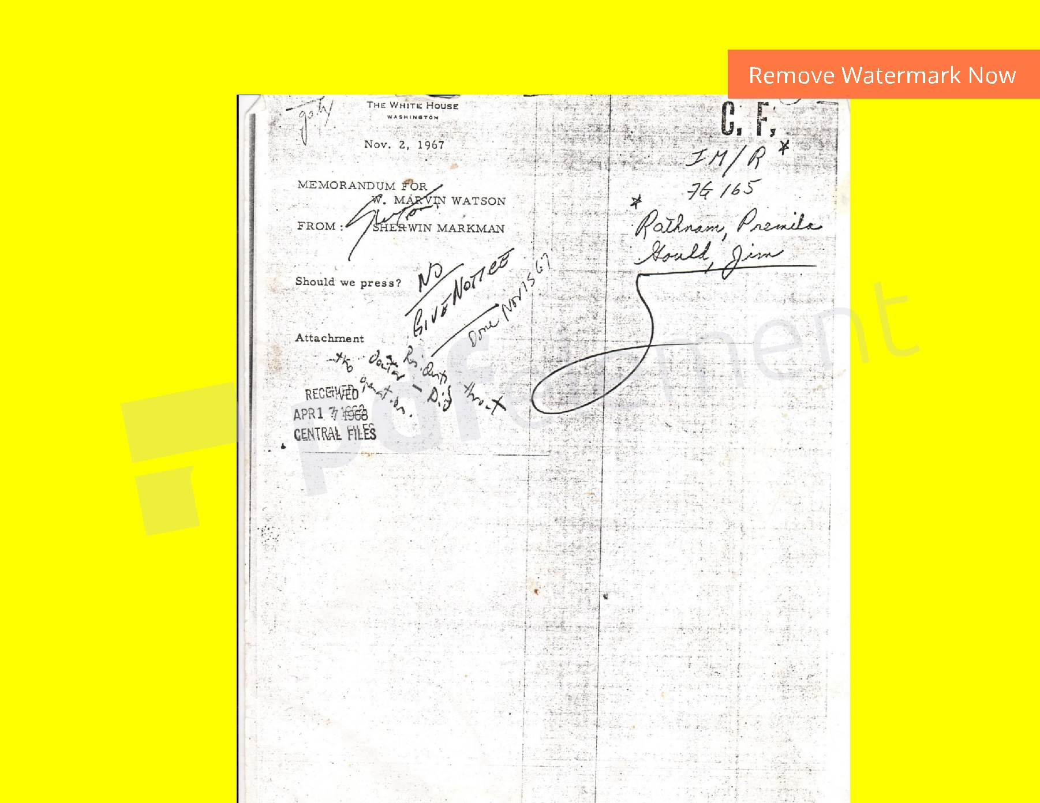
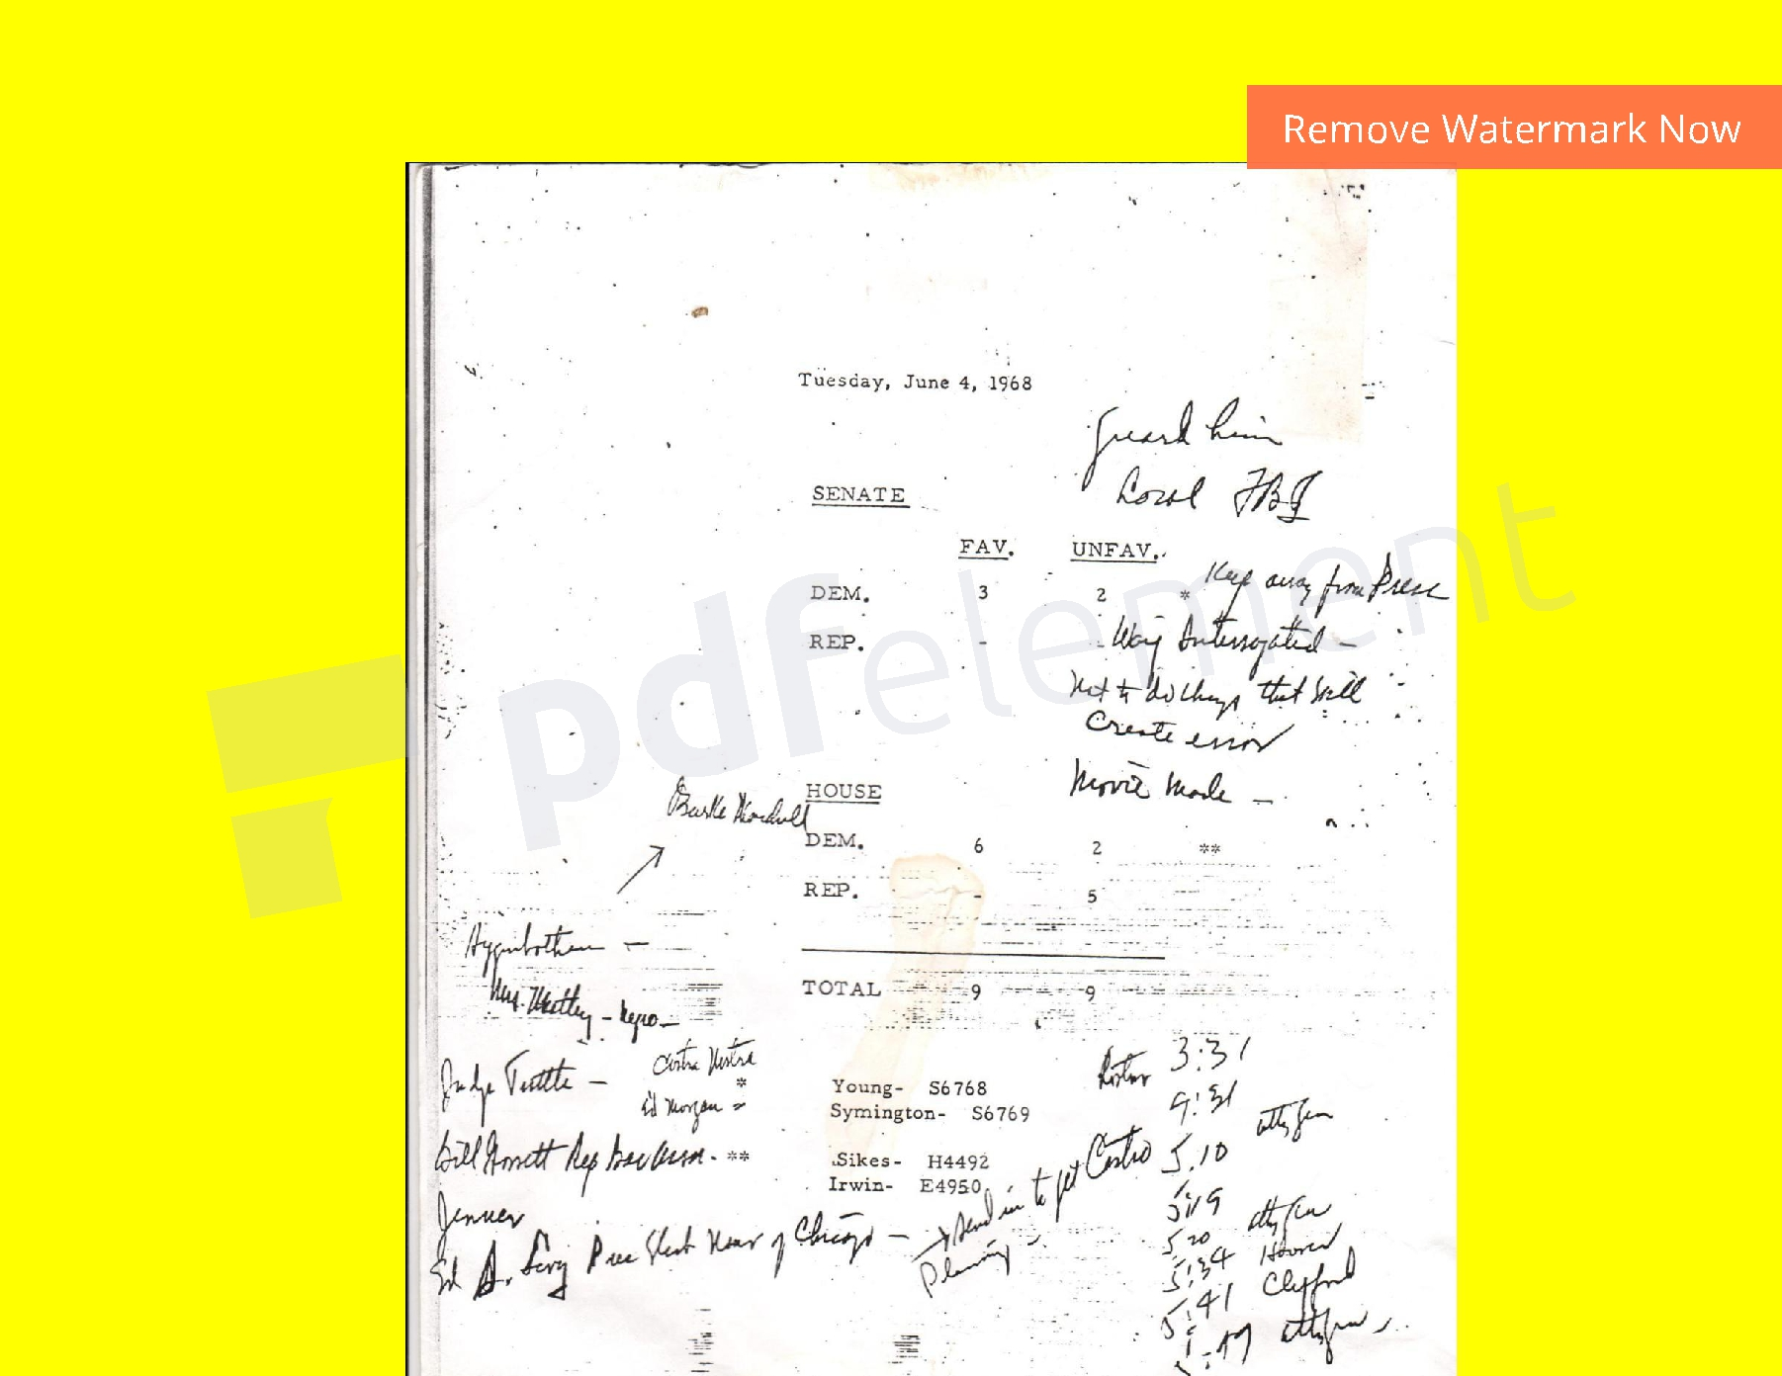

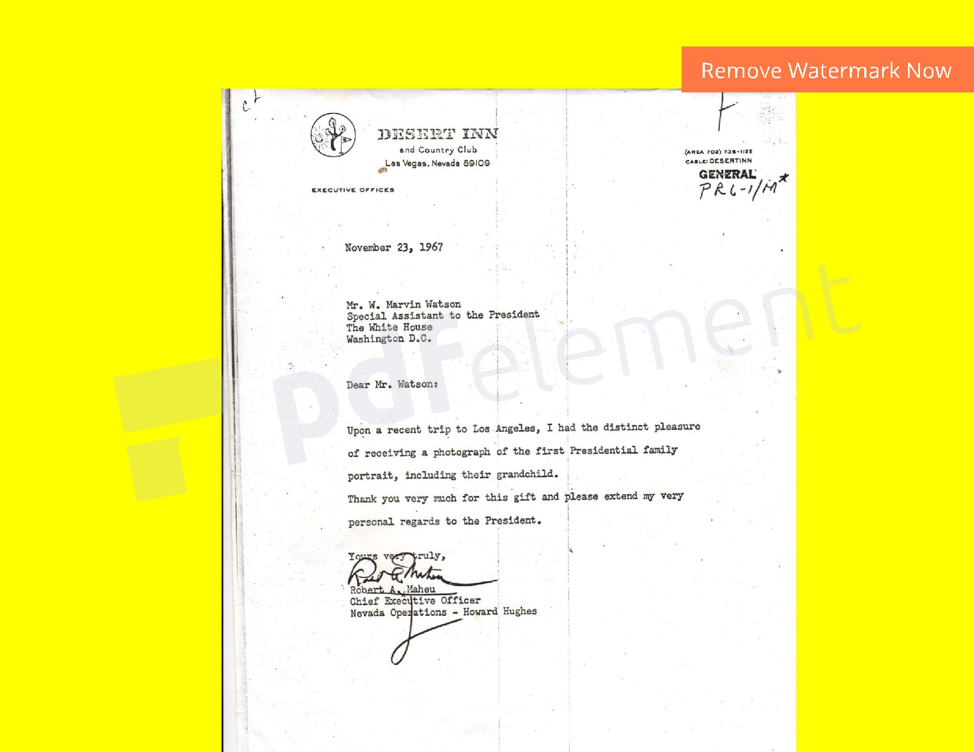

These four documents were found in the 14-million item National Archives in the Lyndon B. Johnson Museum and Library at the University of Texas in Austin by this writer on, February 14, 1992, after three days of search.

Rostow , (a doctor of Economics and Political Science, not of medicine), was President Kennedy’s, ‘foreign policy adviser.’ In 1966 he became the nation’s first National Security Adviser, (“so (Johnson) could, keep an eye on him," according to the late-Sarah McClendon, Grand Dame of the White House Press Corps), and who was succeeded as National Security Adviser by future Secretary of State, Doctor Henry Kissinger, with the Inauguration of President Richard Nixon in 1969.

ROGUE ELEMENTS II

One may notice, at first glance, the handwritten note of LBJ appears to read, ‘President’s throat doctor --- Did the operation.’ Though were it to actually read, ‘doctor,’ the ‘c’ would have curved over at the top of the letter, and the ‘r’ would have ended in a flourish, as may be seen on the June 4, 1968 document, because President Johnson was left-handed. So, it does not read, ‘doctor.’ It becomes apparent that the ‘t’ is crossed twice, once with the stem of the ‘R.’ The ‘w’ on the April 17 document is identical to the ‘w’ on the June 4 document. The note does, in fact, read, ‘ President’s throat Rostow --- Did the operation,’ as confirmed by McClendon, and others.

This was written during a meeting in the Cabinet Room, with Senator Robert Kennedy, Walt Rostow and Ted Sorensen present, on April 3, 1968. (The Reverend Doctor Martin Luther King, Jr., was shot the next day, and his elleged assassin, James Earl Rae, claimed it was, ‘delayed one day.‘) Following President Johnson's surprise announcement on national television that he would not seek his Party’s nomination, Senator Robert Kennedy sent a telegram to the president requesting an urgent meeting. They met, and during the meeting, Secretary of Defense Clark Clifford telephoned the president, who said he was too busy to take the call, but the Secretary said it was, “urgent.” Johnson took the call, and listened as Clifford spoke, and began writing; ‘President ’s throat Rostow --- Did the operation.’ Johnson stood, hung up the phone, and slid the note across the Cabinet Room Table to Senator Robert Kennedy. The senator asked Rostow to come and see if he could make out Johnson’s handwriting. Rostow walked around the table to Bobby, who swung the Vice President’s chair around, and kicked Rostow squarely in his gonads, according to White House photographs of the meeting.

Into the Examination Room at Walter Reed Army Hospital, where President Kennedy briefly lay, there came Walt Rostow, and Naval Lieutenant Commander George Herbert Walker Bush, who ordered the four orderlies to leave, and when they returned, there was an additional, horizontal gash in the president’s throat, according to the four orderlies’ report. The Constitution of the United States reads: ‘It takes four eye-witnesses to the same overt act for a conviction of Treason.’ Bush changed it to read, “…only during wartime.” The shooting of a Chief-of-State, (and the cover-up thereof), IS an act of war, and the now-dead-Bush would have made no effort to change the Constitution were it not for the fact that he is guilty of Treason, and where the penalty is hanged until dead. Bush also changed the U.S. Constitution to read from, ‘An author owns their copyright for fifty years after their death,’ to ‘five years after their death,’ meaning Prince, Michael Jackson, Whitney Houston, and Tina Marie were all worth much more dead than alive.

Doctor Charles Henderson at Parkland Hospital told this writer that he was, “…the first doctor to see the president. I didn’t do a tracheotomy. I did a tracheostomy, and they ordered 40lbs of ice.” The First Lady, who had half of her husband’s brain clutched in her grasp, was told, “Please, Misses Kennedy, we need this.”

Incision below the rifle round, forty pounds of ice to slow the metabolism down so that he would not bleed to death, and a doctor saying that they needed the half of his brain. Cadavers do not need a half of a brain. They had to pry it from the First Lady's grasp, being that she was still in shock. (When the central Cerebral membrane is not broken, there is a good chance of survival.
The 1978 United States House of Representatives Assassinations Sub-Committee Report determined that Lee Harvey Oswald, (the alleged ‘assassin’ of JFK), and James Earl Rae, (the alleged ‘assassin’ of the Reverend Doctor Martin Luther King, Jr.), could not possibly have ‘acted alone,’ and in both cases the shootings were, ‘probably the result of a conspiracy,’ making both (assassinations) ‘open cases.’ What Rostow did not know then was that by removing the rifle round from the president’s trachea, he cleared the airway. Rostow also believed, as many convicts once believed, that he would never be caught.

The second document Johnson used to indict Walt Rostow is an affidavit dated June 4, 1968. It was written during the early hours of June 5. Johnson first initialed it, ‘LBJ,’ when Rostow called the president at 3:31am, informing him that the senator had been shot. Rostow called again at 4:31am, although he denied making the second call, even though White House Daily Diaries record that Rostow called at 3:31, and again at 4:31, exactly as shown on Johnson’s affidavit, and it was pointed out to him, as such, yet he still denied calling the president a second time. Rostow's first call came twenty-seven minutes after Senator Kennedy had been shot in the kitchen of the Ambassador Hotel in Los Angeles.

As Rostow spoke, Johnson began to write, ‘Guard him Carol, (Carol Territto, Johnson’s Archivist), keep away from Press, way interrogated, not to do things that will create error, movie made, Costra Nostra, (La Cosa Nostra/Mafia), Ed Morgan, and, send in to get Castro, planning.’

That was written a full 27 minutes after RFK was shot, allegedly by Sirhan Basra Sirhan. Yet although Sirhan carried an eight-shot pistol, there were ten rounds recovered from Robert Kennedy and the crime scene. An hour later, during the second call to the White House, there is a list of names Johnson had written, some of whom would appear on the “Commission of Distinguished Americans,” formed to, “study this terrible phenomenon of violence and assassination.”
Howard Hughes had written a memorandum to his, ‘aide de camp,’ Robert Maheu, shortly after the senator’s death, saying that this would be the ‘perfect diversion’ away from Hughes’ several anti-trust violations, which were prosecuted by Robert Kennedy when he was Attorney General, and one lawsuit held even after RFK’s death, on June 6, when, two months later, Attorney General Ramsey Clark fined Hughes $216-million for the bogus Hughes helicopter contract. Since Hughes could no longer profit, (indeed lose money on each helicopter lost), Nixon’s strategy quickly changed from a helicopter war to "a ground war," and all this would just be innocuous politics, were it not for the fact that many tens of thousands of brave young men and women met terrible ends, and countless others were severely debilitated, and all too often for the rest of their painful lives.

Upon Robert Kennedy’s death, at 12:04am on June 6th, Hughes had written, ‘It seems to me that this particular moment in the historical passage of time may be the very most ideal time to launch our anti- anti- trust campaign. In other words, I can’t imagine another time, if we waited a year, when public sentiment will be so violently and passionately focused on the need for measures to control crime. Bob, I urge you to contact Justice at once. I just don’t want you to miss this opportunity of mobilizing this intense feeling.’ The result of the ‘Commission of Distinguished Americans’ findings, (some of whom are listed in Johnson’s affidavit of June 4), was the Omnibus Crime Control and Safe Streets Act of 1968, and the nation's first comprehensive gun control measures.

Victor Marchetti is a CIA Analyst, and Soviet foreign aid expert, and Executive Assistant who was involved in the 1962 Cuban Missile Crisis, and who had written, with John D. Marks, THE CIA AND THE CULT OF INTELLIGENCE, which was the first book ever censored before publication by the U.S. government, (and which very well could have been titled, THE CIA v. THE CULT OF INTELLIGENCE). Rostow was named a ‘key figure’ in the Cult of Intelligence. Marchetti makes the case that at least one of Rostow’s books, THE DYNAMICS OF SOVIET SOCIETY, was financed by C.I.A. funds, and reflected the prevailing view of the Agency. It was published in two versions; one for internal CIA, and one for public consumption. Rostow’s book has been criticized for over-estimating Soviet military and industrial strength, and its critics contend this over-estimation completed its intended mission; scare up U.S. defense expenditures.

Maheu served in the Office of State Security, (OSS), during World War II, primarily recruiting Sicilian mobsters to assassinate German officers during the occupation of Sicily. After the war, Maheu set up office in Washington, DC, ‘Maheu Associates, a public relations and investigative agency.’ Hughes had been trying to hire the assassin, Maheu, ever since JFK was first elected, (and narrowly beating his puppet, Richard Nixon), but Maheu and Rostow deferred until after the Bay of Pigs fiasco, when Rostow and Central Intelligence Agency Deputy Director of Intelligence, Richard Bissell, were exiled from the White House when Attorney General Robert Kennedy’s Cuba Study Group blamed Rostow and Bissell for landing the invasion force in swampland fifty miles from the protective hills, (which would have taken them more than three days to reach). Maheu was with Bissell in Guatemala where the doomed, very young men disembarked… and it has been said, the lucky ones died in the artillery barrage on the swamp where they were landed.


Ed Morgan, a close associate of Maheu, was Assistant Director for the Federal Bureau of Investigations, whom Michael Drosnin, CITIZEN HUGHES, contends was a go-between for the FBI and certain mobsters, and later, Hughes. When asked if he knew Morgan and Maheu, Rostow replied, “Never hoid of ‘em!,” which is amazing that a man with a doctorate in political science never heard of them, when it was Morgan who testified before the Senate Watergate, and Senate Intelligence Committees that Maheu was responsible for the several bungled attempts on the life of Cuban President Fidel Castro.

Maheu learned of President Johnson’s super-secret Executive Investigation, and had written a letter to LBJ’s Assistant, Marvin Watson, dated November 23, 1967. It is a blatant threat on LBJ’s ‘grandchild,’ who was a two-year-old girl, and which most likely precipitated Johnson’s retreat to his Texas ranch in the summer of 1968. Maheu visited Johnson with an offer from Hughes to finance LBJ’s entire Library, and where Johnson reportedly told Maheu to tell Hughes, “Shove it!”

Dear Mr. Watson,

Upon a recent trip to Los Angeles I had the distinct pleasure of receiving a photograph of the first Presidential family

portrait, including their grandchild.

Thank you very much for this gift and please extend my very personal regards to the President.

Yours very truly,

(Signed) Robert A. Maheu

Chief Executive Officer

Nevada Operations --- Howard Hughes.

As recently as 1995, former Nixon Secretary of State Henry Kissinger, and former Kennedy Secretary of Defense Robert McNamara, jointly renounced those early decisions that resulted in the fall of Saigon, with McNamara claiming the assassinations of

Viet Nam’s President Ngo Diem and Generalissimo Omar Trujillo of the Dominican Republic were conducted by “rogue elements”
within CIA. (Maheu was responsible for, with State Department, (Rostow), sanctions, ‘the entire personal security system of the Generalissimo.’ Trujillo was, ‘gunned down by his own security forces.’

When asked who he thinks shot JFK, Rostow replied, “I think it was the Cubans!” When asked if he was in Parkland Hospital the day President Kennedy was shot, he said, “No… I was in Arlington.” When asked, ‘So, you were in Walter Reid Army Hospital, then, weren’t you?” He replied ominously, “No, I, uh… I think we better end this conversation here, Mister Dodge.” When asked if I could, “call him in a couple of weeks,” he totally snapped, and then snarled, “YEAH! CALL ME IN A COUPLA WEEKS! “Okey dokey,” I says, hung up the phone, and got right the heck out of Austin, Texas, with a deadly, very pissed, and self-described, “old CIA man,” hot on my heels. That was February 14, 1992; ‘Valentine’s Day.’

I swiftly evaded him, many, many times over the course of the past twenty-six years, and he eventually died, and I survived to write about it, here… and they don’t call me ‘Dodge’ for nothing, and like the first Dodge, in 1306, who was knighted ‘Sir Peter Dodge’ for ‘swiftly evading the enemy, and giving a good report to the King,’ I, too, swiftly evaded the enemy, and gave what I thought was a good report to the president. For this, I was not knighted, but damn near killed… about a dozen times, and it all began when Bill Clinton, in his first press conference, was shouted at by Sarah McClendon, “Whadya think a Walt Rostow?!” The fresh, young president pointed his crooked finger at Sarah, and said, ‘Shhht!’ “But.., “ she said, and Bill moved menacingly closer, and again the crooked finger, and said, “SHHHT!” Twenty-four hours later, Live, again, on CSPAN, Bill condescendingly asked, “Sarah? You have a question you’d like to ask?” “Whadya think a Gary Dodge?!” Bill snorted, and again with the crooked finger, said, “He thinks he’s God. I’m not kidding, he thinks he’s God!” Well, it looks like Bill got some faulty Intelligence, because that’s old news, and I have never thought that I was God. I did have a mild Messianic Complex, because I heard somewhere that ‘Christian’ means ‘Christ-like,’ and I wanted to live a life in Christ. Impossible to do in these United States, though, where there are just too many temptations…
I fancied myself a ‘dragon slayer’ dating back to my youth as a reporter for a small-town daily, where I delighted in a few dragon slayings, and I must say, though the pay was minuscule, the job satisfaction was immense…

CASE CLOSED

Michael Beschloss had written a book about the JFK ‘assassination,’ and he called it, CASE CLOSED. He makes the ‘case’ that Lee Harvey Oswald ‘acted alone.’ No doubt Beschloss never heard of the 1978 House Assassinations Sub-Committee Report, which stated that the shootings of both President Kennedy, and the Rev. Dr. King, were, ‘probably the result of a conspiracy,’ meaning, therefore that both Oswald, and James Earl Rae could not possibly have, ‘acted alone,’ according to the debunked, Warren Commission.

Beschloss’s form of journalism is not reportage. It is propaganda, and he is just a typist. It is a miserable state-of-affairs that began with the attempted assassination of President Ronald Reagan by John David Hinckley, Jr., who has not spent one day behind bars, as planned, because he pleaded insanity. John David Hinckley, Sr., was in the oil services business in Houston, Texas. President George Herbert Walker Bush, before he became a political hack, was in the oil services business in Houston, too. Bush began his political career as a U.S. Representative from Amarillo, Texas, then United States Ambassador to the United Nations, then CIA Director, then Vice President, then President. If Reagan had died, Geo. H.W. Bush would have been the longest term president in U.S. History, if he had been re-elected. He lost to Bill Clinton in 1992.

Sirhan, fittingly, got life in prison, (and who was originally given the death penalty, but California abolished the death penalty), because he has since claimed that the shooting to death of Senator Robert Kennedy was, ‘a conspiracy.’ James Earl Rae had written, WHO KILLED THE REVEREND DOCTOR MARTIN LUTHER KING, JR?, who also claimed it was, ‘a conspiracy.’

It is too bad Rostow had to up and die on me, because I had a few more questions for him… such as, “How could (he) possibly not heard of Ed Morgan, who was counsel to the Senate committee which investigated Senator Joseph McCarthy’s charges against the State Department?” He obviously had something to hide. According to Drosnin, Maheu had, ‘a White House connection’ for the drug addicted, mega lo-maniacal, demented, and thoroughly corrupt Hughes. Rostow was his White House connection. ‘Planning,’ was signature Walt Rostow. In Volume 10, Page 77, of the 1978 House Sub-Committee Report, Rostow is said to have proposed a ‘track two’ approach to the clandestine operations against Castro:

‘The concept of autonomous operations was conceived by Walt Rostow, State Department counsel. This approach would enable financial aid, advice, and guidance to anti-Castro Cuban exile groups. (Autonomous operations were approved in June, 1963.) Operations were to be executed exclusively by Cuban Nationals dedicated to the idea that the overthrow of the Castro/Communist regime and must be accomplished by Cubans inside and outside Cuba working in concert. If the effort to overthrow the Cuban regime became too costly in human lives, the United States would withdraw financial support and would not consider resumption at any future date . All operations had to be mounted outside the United States. If ever charged with complicity, the U.S. Government would publicly deny any participation in the group’s activities.’ An inside source provided information on Cuban exiles, “meeting with Attorney General Robert F. Kennedy in September, 1963.”

A cache of weapons under Rostow’s control was dispatched to Galveston, Texas, for pick up by a Cuban National and destined for Cuba on November, 23, 1963, but the shipment was (inexplicably) moved up two days. The Cuban National reported not to have received these weapons, destined for Cuba. The Cuban National gave no credible reason for the failure to pick up these weapons on November 21, 1963, in Galveston, Texas.Where, then, did the weapons under Walt Rostow’s control end up almost exactly twenty-four hours before President Kennedy was shot, multiple times, one-hundred miles due north of Galveston, in Dallas, Texas?

ONE FINAL NOTE ON THE RELEVANCE OF THE ‘PRESIDENT’S THROAT ROSTOW --- DID THE

OPERATION’ DOCUMENT

If one were to produce a photograph of Walt Whitman Rostow emerging from the Examination Room at the Walter Reid Army Hospital where the president lay, briefly, on November 22, 1963, it would not equal this document, which places Rostow’s hands IN the President’s throat, and catching him, literally, red-handed. This coupled with the fact that they are the words of a dying man, and not just any dying man, but an eye-witness to the shooting, and President of the United States, makes this document prima facie evidence to convict, in absentia, Walt Whitman Rostow. In addition, he never professed his innocence, (because he could not), and instead embarked upon a terrific smear campaign, (domestic counterintelligence), in order to marginalize me, and/or kill me, by proxy.

After the 1978 House Assassinations Sub-Committee Report, the one remaining question for the scores of professional and amateur investigators was, (as of October, 1983), ‘If it was a conspiracy, and JFK was hit first in the throat, then who did the operation on the president’s throat which removed a rifle round of indeterminate caliber?’


The now-dead Walt Whitman Rostow, that’s who. His brother, Eugene, was Chairman of the Board of the Cult Awareness Network, (CAN), which promised to, ‘Kidnap brainwashed youth from the clutches of ‘The Moonies,’ deprogram them, and return them to their loving families, as good as new.’ CAN was cover for WETWORKS; the “CIA domestic assassination and dirty tricks squad.” (A squad is a four- person team, and the CIA has been barred from operating domestically since 1974.) Eugene was also Dean of the Yale School of Law, and ‘mentor’ to the young William J. Clinton, who graduated the Yale School of Law in a remarkable three years… Eugene is dead now, too.

Ethnobotanist Wade Davis, THE SERPENT AND THE RAINBOW, recounts being, “…summoned to a major East Coast University,” (Yale), and, "met by two very well-dressed, but very strange men, " (Walt and Eugene Rostow), who asked (him) to,
"Go to Haiti and find the secret to Voodoo Death.” He did, and returned to write the book, which was bastardized by Hollywood, and no wonder there: Jack Valenti, (President of the Motion Picture Association, until his death), was White House Assistant to Walt Rostow in the Johnson years. The essence of Voodoo Death is to first stigmatize, then marginalize, then ostracize, demonize, and ultimately victimized to a statistic. Much like AIDS…

The Bros. Rostow used this to ill effect against gays, minorities, and young minority women, not for who they are, but for how they vote,

which is usually Democratic. Walt’s life-long, and deadly assault on popular Democrats, (and their constituencies, in all manner of dirty

trickery), has left a trail of innocent blood, and tragic loss, long and wide, and who was a prolific serial killer and an insane Mass Murderer,

besides, earning the moniker: Satan of the twentieth century. According to the PEOPLES ALMANAC , an Actuary calculated that for all

eighteen material witnesses to die violent deaths in the period 1963 – 1968, the odds were 100,000-trillion:1

Clinton Global Initiative announced, “Young African American women are the next demographic, (constituency?), at risk for contracting HIV/AIDS Disease,” while an AIDS Industry glossy’s cover reads, ‘Are Latinos the next demographic at risk?’ It would appear the only demographics at risk for AIDS are solid Democratic voting blocs. While AIDS first appeared in 1984, and the demographics have remained largely the same for lo’ these many years since: Gays, Blacks, and other Democrats. All three demographics have one over-riding reason to be marked for destruction; Not one person will ever, ever vote Republican...

NOTHING NEW UNDER THE SUN


Matthew, Ch. 5, v 25, And there once was a woman who had an issue of blood for twelve years, and who was attended to by many physicians, but did not get better but grew worse, and who spent all she had. “If I may touch the hem of his garment, I will be healed,” she said. “…Daughter, your faith has healed you. Go in peace and be free from your suffering.”

Ecclesiastes, Ch. 1, v 19: That which has been is what will be, that which is done will be done, and there is nothing new under the Sun.

There are many scientists and professionals who dispute the HIV/AIDS Hypothesis, and it is called an ‘hypothesis’ because there have never been clinical trials for the current treatment, and no papers have been submitted to leading medical journals, subject to peer review. There have been only news conferences. Indeed, the AIDS fraud started with a news conference April 23, 1984, with Doctor Robert Gallo, a researcher with the National Institutes of Health* in conjunction with the U.S. Department of Health and Human Services, (HHS). He used this forum to announce his discovery of a new retrovirus described as, “the possible cause of AIDS.” Although Gallo presented no evidence to support his tentative assumptions, HHS immediately characterized it as, “Another miracle of American medicine… the triumph of science over a dreaded disease!” Later that day, Gallo filed a patent for the anti-body test, known as the ‘AIDS test.’ By the following day the New York Times had turned Gallo’s proposal into a certainty, with Front Page news of “The virus that causes AIDS,” and all funding for research into other possible causes for AIDS came to an abrupt halt.

Doctor Luc Montagnier, of the Pasture Institute in France, accused Gallo of stealing his sample, sent to him by Montagnier. A congressional investigation determined that Gallo had presented fraudulent data in his original paper on HIV, and that the virus he claimed to have discovered was sent to him by Montagnier.

Negotiations were conducted by the French and American governments to establish discovery and patent rights. These ended in a compromise, with Montagnier and Gallo sharing credit as the co-discoverers of HIV and ownership rights to the AIDS test. The good doctor, Montagnier, has since stated that he does not believe HIV alone is the cause of AIDS.

The late- (and very brave), Christine Maggiore authored, ‘WHAT IF EVERYTHING YOU THOUGHT YOU KNEW ABOUT AIDS WAS WRONG? Maggiore had written: ‘AIDS is a category, not an illness… There are 29 familiar conditions in the category, including pneumonia, yeast infection, salmonella, and certain types of cancers. None of these conditions appear in persons who test HIV positive; all appear in persons who test HIV negative. And finally, all AIDS conditions have documented causes and treatments that are not related to HIV.’

*The National Institutes of Health was originally established by Howard Hughes as a tax write-off. NIH had one benefactor, (Hughes), and one beneficiary, (Hughes), who died, in 1976, in the air, in a private jet over Mexico City, ‘for lack of proper medical attention.’

REFERENCES

THE CIA AND THE CULT OF INTELLIGENCE

Victor Marchetti and John D. Marks

CITIZEN HUGHES

Michael Drosnin

Holt-Rinehart, 1984

HOLY BIBLE

King James Version

HOLY BIBLE

New International Version

Zondervan Publishing Company, 1983

THE ART OF WAR

Sun Tzu

Translated and with an Introduction by Samuel B. Griffith

Oxford University Press, 1984

THE ORIGINS OF WAR: From the Stone Age to Alexander the Great

Arthur C. Merrill

Oxford University Press, 1984

The U.S. House Assassinations Sub-Committee Report, 1978

The National Archives in the Lyndon B. Johnson Museum and Library at the University of Texas in Austin,

Central Files, 1968

THE VULGATE & APPENDIX TO THE VULGATE
St. Jerome, 4th Century

WHAT IF EVERYTHING YOU THOUGHT YOU KNEW ABOUT AIDS WAS WRONG?

Christine Maggiore

The American Foundation for AIDS Alternatives

Fourth Edition Revised, 2000


THE PEOPLES ALMANAC

Irving Walescewski and David Wallace

The father and son team who authored
this fully extraordinary, and highly skilled,
work-of-journalistic-art, in 1969…

The Author

b. August 2, 1958, next to the colorful, and pristine mountains of Newport, New Hampshire, (Kennedy territory), where one of my earliest memories was being sent home early from Kindergarten to find my Dear Mother sitting on the edge of the couch, in front of the television, and with her face in her hands, crying, and crying. The president had been shot. My Dear Father taught me how to read a newspaper, (the statewide daily, the MANCHESTER UNION LEADER), by the age of three. I would become a big reader of his excellent collection of History books. At the age of twelve, I had the opportunity to read one of my Dear Father's History books, where I saw this quote from Napoleon Bonaparte: "I fear three newspapers more than ten-thousand armies." Right then and there,
I wished to be a newspaperman, and feared by emperors and assorted scumbags everywhere…

